**Create a react application to display the output as show in the screenshot.**

Watch: <https://www.youtube.com/watch?v=_YQ_F5T0_f8>

1. The above given output contains four function components, (locate them in the given snippets)
   1. **Home**

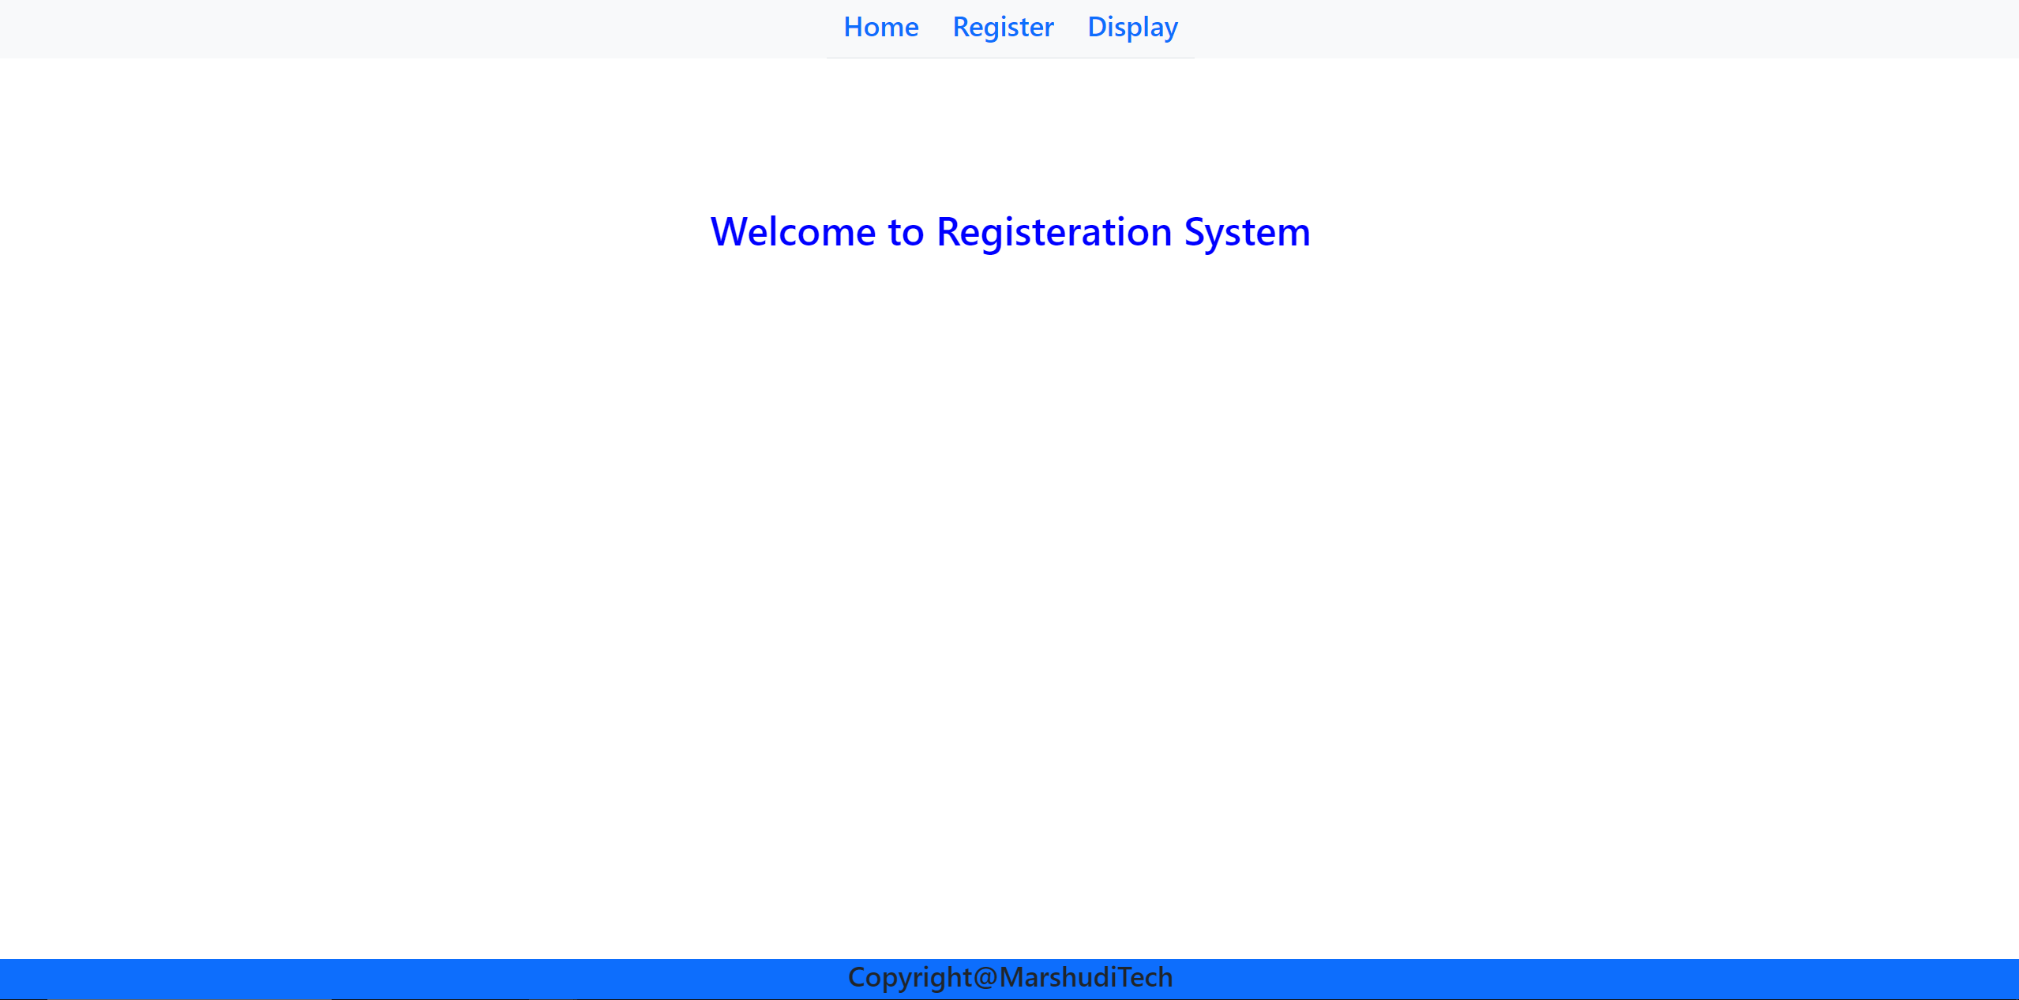

* 1. **Register**

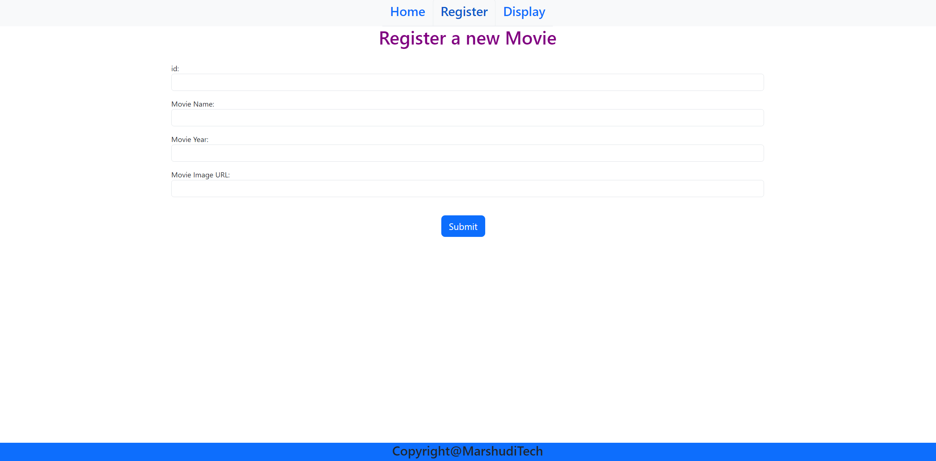

* 1. **Display**

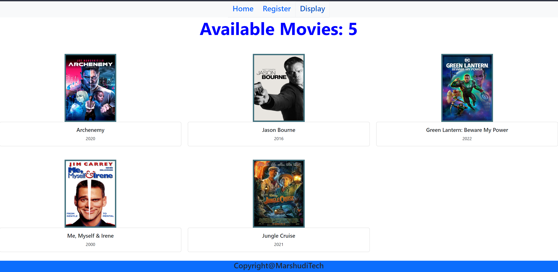

* 1. **Footer**
     + Copyright@**YourStudentID**

1. All components must be present in **App.js**

Create a folder with your ID, place the **src** and **public** and **server** folders from your project, compress and upload it on the e-Exam link

**Note:** You can use the given code snippets in appropriate places along with the required modifications to show the desired output.

**NOTE: They my give you this on final and may not!!**

**Install the required packages from the following.**

**Client:**

* bootstrap
* axios
* react-router-dom@lates

**Server:**

* express
* mongoose
* cors
* mongodb

**Client**

**import snippet**

import "bootstrap/dist/css/bootstrap.min.css";

import "bootstrap/dist/js/bootstrap.bundle.min";

import {BrowserRouter, Routes, Route, Link} from "react-router-dom";

**Code snippet**

<div className='header'>

          <nav className='nav nav-bar bg-light justify-content-center'>

              <ul className='nav nav-tabs'>

                <li className='nav-items'><h3>Home</h3></li>

                <li className='nav-items'><h3>Register</h3></li>

                <li className='nav-items'><h3>Display</h3></li>

          </ul>

        </nav>

</div>

data inputs to display the given information.

________________________________

mid:1

movieName: Archenemy

movieYear: 2020

moviePic: <https://encrypted-tbn2.gstatic.com/images?q=tbn:ANd9GcR85LxTxW44OOMXaJJHpHQ6QyN64BbcDIiCOOE-LvEECQJ7eBgy>

_______________________________________

mid:2

movieName: Jason Bourne

movieYear: 2016

moviePic: <https://encrypted-tbn1.gstatic.com/images?q=tbn:ANd9GcQidbcqrpW2e6MYtz5XKGsvRFdfUa88fCL_3fvafEOP6JksQudS>

_______________________________________

mid:3

movieName: Green Lantern: Beware My Power

movieYear: 2022

moviePic: <https://encrypted-tbn2.gstatic.com/images?q=tbn:ANd9GcQPN3ulCde2B0N5yWiYX2hp7L_VxBSHr13B3nnuQoaXkcIEl8FT>

_____________________________________

mid:4

movieName: Me, Myself & Irene

movieYear: 2000

moviePic: <https://encrypted-tbn2.gstatic.com/images?q=tbn:ANd9GcTpGyNa6XBbAgCgEJ6TkZl1G3I4s6kjJOqWzSJGzC8Fsxdme-OQ>

___________________________

mid:5

movieName: Jungle Cruise

movieYear: 2021

moviePic: <https://encrypted-tbn3.gstatic.com/images?q=tbn:ANd9GcTJVZIdHZB9hsM-jEq8yg5zyznyKuzXgR03njWF-11mUrAr4Uqm>

**Register components**

                <div className='container '>

            <h1 style={{textAlign:"center", color:"purple"}}>Register a new Movie</h1>

            <br/>

            <p>id: <input ></input></p>

            <p>Movie Name: <input ></input></p>

            <p>Movie Year: <input ></input></p>

            <p>Movie Image URL: <input ></input></p>

            <br/>

            <button>Submit</button>

            <br/>

            <h4</h4>

        </div>

**Display components**

import React from "react";

export default function Display() {

    return(

        <>

            <h1 class="display-3 text-center" style={ } >Available Movies: { }</h1>

            <div class="row row-cols-3">

                <Items />

            </div>

        </>

    );

}

**Movie Card**

                <div>

                    <div class="grid col">

                  <img src=”Movie image” class="card-img-top" style=”image style” />

                    </div>

                    <div class="col">

                        <div class="card text-center">

                                <div class="card-body">

                                <h5 class="card-title">movie name</h5>

                                <p class="card-text">movie year</p>

                            </div>

                        </div>

                    </div>

                </div>

**Style snippet**

    const titleStyle = {

        color : "blue",

        fontWeight: "bold"

    }

    const imgStyle = {

        width:"150px",

        height:"150px",

        borderRadius:"50%",

        marginLeft: "auto",

        marginRight: "auto",

        display: "block",

        marginTop: "50px",

        border: "5px solid #adadad"

    }

**Server**

**Note: They may give you this code or may not be aware of that**

import mongoose from "mongoose";

import cors from "cors";

import express from "express";

//import your model file

////////

const app=express();

app.use(express.json());

app.use(cors());

const conStr=" ";

mongoose.connect(conStr,{

    useNewUrlParser:true,

    useUnifiedTopology:true

})

app.listen(3001,()=>{

    console.log("server is running...on port 3001");

})

//app.post()

//app.get()